**Expert ID/Name: Nstructive**

**Date: 05-Nov-2020**

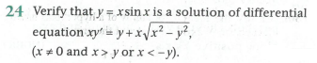

**Answer:**

|  |
| --- |
| **Section 1:** Algorithm/Theorem Reminder / A tip for solving these type of questions |
| 1. Differentiate the function  with respect to “x” on both sides in one time. 2. Substitute the value of  in  and verify . |

|  |
| --- |
| **Section 2:** Step-by-step answer |
| Given:  To verify: The function  is a solution of differential equation  Explanation:  Step 1:   |  |  | | --- | --- | | Instruction | Take and do differentiate with respect to “x” on both sides. | | Calculation |  |   Step 2:   |  |  | | --- | --- | | Instruction | Substitute the value of  in | | Calculation | Given,  and | |

|  |
| --- |
| Conclusion: The function  is a solution of differential equation |
| Hence, verified. |